**PROJECT REPORT**

**ON**

**HYDROGEN STORAGE IN CARBON NANOFIBERS**



REPORT SUBMITTED

TO

VISHWAKARMA INSTITUTE OF INFORMATION TECHNOLOGY, PUNE

FOR THE PBL OF ENGINEERING CHEMISTRY

IN

**DEPARTMENT OF ENGINEERING AND APPLIED SCIENCES**

**AY 2020-21**

**Semester I**

BY

**Rudraprasad Vishwamitre- 7049/ 22010802**

**Deep Jadhav- 7050/ 22010818**

**Dhaval Bora- 7062/ 22011010**

**Akshay Misal- 7064/ 22011042**

**Class: F.Y.B-Tech Division: G Batch: G-3**

**Batch Teacher-** Prof. Aparna Kulkarni

**INDEX**

|  |  |  |
| --- | --- | --- |
| **Sr. No.** | **Contents** | **Page No.** |
| **1** | **ABSTRACT** | **3** |
| **2** | **OBJECTIVES** | **3** |
| **3** | **INTRODUCTION/THEORY** | **3,4** |
| **4** | **EXPERIMENTAL METHODS (PROPOSED/USED)** | **5,6** |
| **5** | **EXPERIMENTAL DETAILS** | **6,7,8,9** |
| **6** | **RESULTS AND DISCUSSION** | **10,11,12** |
| **7** | **CONCLUSIONS** | **13** |
| **8** | **Limitations(as applicable) and future scope** | **13** |
| **9** | **REFERENCES** | **14** |

1. **ABSTRACT**

It is well known that three challenges of hydrogen economy, that is, production, storage, and transportation or application put tremendous stress on scientific community for the past several decades. Based on several investigations, reported in literature, it is observed that the storage of hydrogen in solid form is more suitable option to overcome the challenges like its storage and transportation. In this form, hydrogen can be stored by absorption (metal hydrides and complex hydrides) and adsorption (carbon materials). Compared to absorption, adsorption of hydrogen on carbon materials is observed to be more favourable in terms of storage capacity.

Taking in to account of these facts, in this short review, an overview on hydrogen adsorption on activated carbon and different allotropes of carbon like graphite, carbon nanotubes, and carbon nanofibers is presented. Synthesis processes of all the carbon materials are discussed in brief along with their hydrogen storage capacities at different operating conditions, and thermodynamic properties and reaction kinetics. In addition, different methods to improve hydrogen storage capacities of carbon materials are presented in detail. Finally, comparison is made between different carbon materials to estimate the amount of hydrogen that can be stored and retract practically. The experimentally measured maximum hydrogen storage capacity of activate carbon, graphite, single-walled nanotubes, multiwalled nanotubes, and carbon nanofibers at room temperature are 5.5 wt%, 4.48 wt%, 4.5 wt %, 6.3 wt%, and 6.5 wt%, respectively.

**2. OBJECTIVES**

1. Introduction hydrogen storage in carbon material
2. Study of structural arrangements of carbon Nano filaments and their synthesis
3. Experimentally measured hydrogen storage capacities of carbon nanofibers
4. Treatments for improving storage capacities of different carbon materials
5. To study the hydrogen adsorption under the flow [ dynamically]
6. Results and discussions of experiments carried out respectively

**3. INTRODUCTION/THEORY**

Energy is one of the major inputs for the economic development of any country. On one side, World’s requirements are increasing due to the growing population and changes in living styles, and on the other side, the natural resources are depleting at an alarming rate together with environmental issues. In fact, the environmental destruction brought about by the consumption of fossil fuels has led to a hike in the demand for clean and sustainable energy. In such a scenario, hydrogen as a fuel comes into the picture to fulfil the energy requirements. Due to the ability of hydrogen to carry high gravimetric energy density with zero emissions and regenerative nature, it serves as a clean energy carrier, thereby being eco-friendly also. From a futuristic perspective, hydrogen is predicted to be an efficient alternative fuel that can be utilized widely in different sectors.

However, the production of hydrogen is not conveniently obtainable; also, the hydrogen technology suffers the major challenge of its storage and transportation. Hydrogen can be stored in three ways: compressed gas, as a cryogenic liquid, and as solid-state storage.1 In the first way, a large storage tank is required coupled with the availability of highly pressurized gas, thereby requiring high compression energy as hydrogen gas occupies large volume. In the second method, as a cryogenic liquid, it requires a high financial investment and the process always consists of various losses like boiling off during refilling, and so on. Therefore, economical and safety aspect of hydrogen storage brought the interest of several researchers toward its solid-state storage through adsorption and/or absorption on materials/alloys. Storage of hydrogen in solid form is considered as safest mode in which hydrogen combines with materials through physisorption or chemisorption. The solid-state hydrogen

**[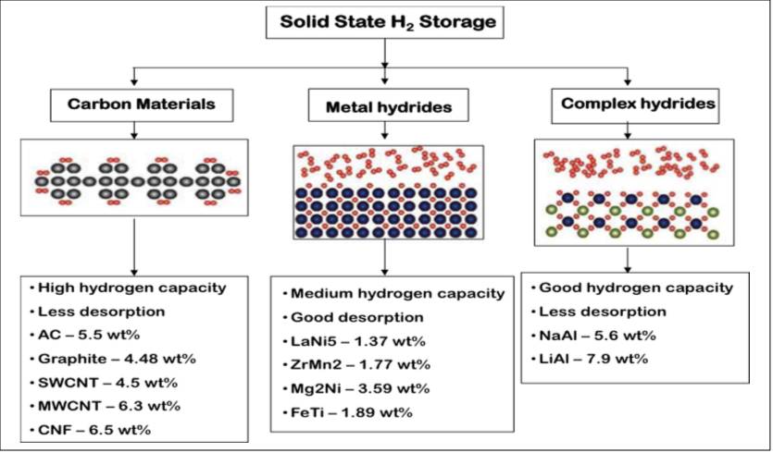](https://onlinelibrary.wiley.com/doi/full/10.1002/est2.35)**

**Synthesis of CNF:**

1. CNF structures can be formed at elevated temperatures from the mixture of carbon contained gases and hydrogen.

[](https://onlinelibrary.wiley.com/doi/full/10.1002/est2.35)

1. Different types of CNF with difference in morphology, crystalline structure, and shape are possible by varying nature and geometry of catalyst as well as reaction condition.
2. The surface A of catalyst particle B absorbs the hydrocarbon, where C-C bonds are broken.
3. Diffusion of carbon atom takes place at interface C, which lies between the platelets D and the catalyst particles, yielding carbon nanostructure.
4. Since the grown fibres are composed of CNFS and the catalyst particles, leaching the catalyst with acid purifies it. The platelets that formed during the entire process have graphite in majority.
5. Hence, the nanofibers are also known as CNFs. Less ordered carbon could also be generated depending on the crystal faces of catalyst.

**4. EXPERIMENTAL METHODS (PROPOSED/USED)**

1. **Hydrogen Storage in Graphite Nanofibers**

An ideal solid for hydrogen storage would possess a structure consisting of slit-shaped nanopores having a width slightly higher than the kinetic diameter of hydrogen, 2.89 Å. To this end, metal-intercalated graphite has been considered as a possible candidate for the storage of hydrogen. It has been reported that up to 0.137 L (STP) of hydrogen per gram of carbon can be adsorbed between the layers of alkali-intercalated graphite, and no evidence of damage to the structure upon repeated adsorption and desorption cycles was observed at liquid nitrogen temperature The interaction of molecular hydrogen and its various isotopes with graphite surfaces has been the subject of extensive research.15-17 Experimental and theoretical studies have indicated that hydrogen chemisorbed on graphite adopts a symmetrical x3 × x3 superstructure at sub monolayer overage. At near monolayer coverage, this configuration disappears and is replaced by an incommensurate triangular phase with reference to Fig 1

[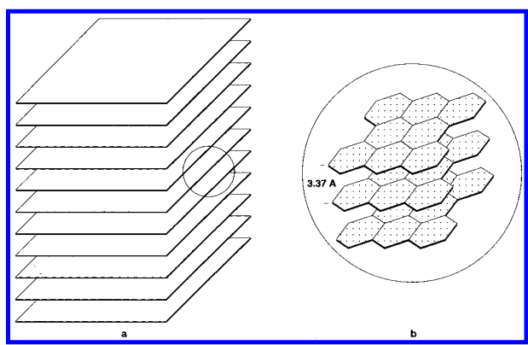](https://www.sciencedirect.com/science/article/abs/pii/S0360319916333602)

Figure 1 (a) Schematic representation of the arrangement of platelets in a catalytically grown graphite nanofiber;

(b) an enlarged section showing the detail of area marked in (a)

The unique conformation of GNF, consisting of platelets having virtually only edges exposed, bestows this material with unique properties that are highly desirable for gas sorption applications. Indeed, these structures comprise an array of slit shaped pores separated by a distance greater than or equal to 3.35 Å and, as such, possess the ideal configuration for use in the storage of hydrogen, whose kinetic diameter is only 2.89 Å. A clearer understanding of the structural features of the nanofibers are shown in the schematic renditions, Figure 1a, b. X-ray diffraction analysis coupled with electron diffraction indicated that prior to adsorption experiments the spacing between platelets for nanofibers that were suitable for hydrogen storage was 3.37 Å

1. **H2 adsorption study under flow (dynamic) conditions**

Nickel (Ni) metal-containing microporous and graphitic carbon nanofiber (CNF)-based adsorbent was prepared for the first time as a hydrogen (H2) storage material. Ni was in situ dispersed in the activated carbon microfiber (ACF) substrate and it served as the chemical vapor deposition catalyst to grow CNFs on the ACF. The prepared ACF/CNF multi-scale web was modified using steam to increase the BET surface area (SBET) and micro porosity content of the material. The H2 storage capacity of the materials was determined at different temperatures (77, 273 and 298 K), and under batch (static) and dynamic (flow) conditions. The comparative data revealed that the SBET of the materials controlled the storage capacity at cryogenic temperature.

The positive effects of the graphitic CNFs and the inclusion of metal (Ni) in the materials were evident at elevated temperatures (273 and 298 K). The H2 uptakes under dynamic conditions were determined to be approximately the same as under batch conditions, indicating that the prepared materials can be efficiently used as adsorbents for H2 under flow conditions.

**5. EXPERIMENTAL DETAILS**

1. Experiment Analysis of Hydrogen Storage in Graphite Nanofibers

High-pressure sorption studies of various types of graphite nanofibers were performed in a specially built apparatus that is shown schematically in Figure 2. The unit consists of a conventional high-pressure stainless-steel sample cell, measuring 22.66 mL including void space, which was connected to a 75.31 mL high-pressure hydrogen reservoir container via a high- pressure bellow valve. Several blank tests were carried out over a 24 h period by pressurizing the unit, which confirmed that the system was leak-free. Calibration of the system to account for the pressure drop brought about by the increase in volume upon opening of the valve between the reservoir and the evacuated sorption cell at various initial pressures was also carried out at this stage. The volume of gas contained in the system at various pressures in the absence of graphite nanofibers was precisely determined by allowing it to exit the system and then measuring by displacement of water.

Approximately 0.2 g of different types of graphite nanofibers, produced from a variety of metal/hydrocarbon systems, was loaded into the sorption cell, and the sample was evacuated to 10-3 Torr while being heated to 150 °C. Hydrogen was then introduced into the reservoir container and subsequently allowed access to the sample chamber for interaction with the nanofibers. The drop-in pressure of the system from an initial value of up to 112 atm was measured at regular intervals with a Cole Parmer meter. The amount of hydrogen stored in graphite nanofibers was calculated from the changes in pressure following interaction of the material with the gas. In a second set of experiments, an identical procedure was used to determine the hydrogen sorption characteristics of palladium powder, two metal alloys (LaNi5 and MnNi4.5Al0.5), and active carbon and graphite. In all cases the experiments were performed at room temperature

[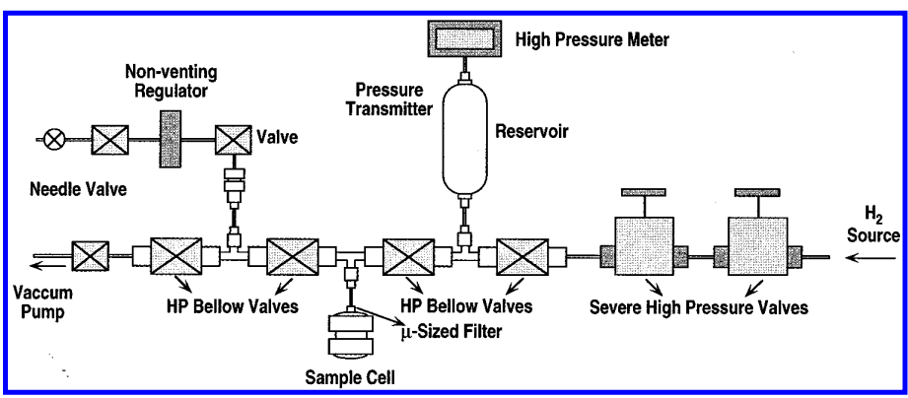](https://www.sciencedirect.com/science/article/abs/pii/S0360319916333602)

Figure 2 Schematic representation of the apparatus used for the measurement of hydrogen uptake in various materials

When purified graphite nanofibers samples were allowed to interact with hydrogen at 25 °C and an initial pressure of 112 atm, a drop in the pressure was observed over a period of 24 h, the degree of which was found to be dependent upon the origin of the sample, and this feature is presented in Figure 3, where the profiles of a selected number of samples are shown. The volumes (STP) and corresponding weight percentages of hydrogen uptake by these and other samples as determined from pressure decline are given in Table 1. The data obtained from these experiments for graphite nanofibers can be compared with those found for the other set of materials. In these latter systems it is apparent that only modest changes in the pressure were observed over the same time period. The dramatic decrease in pressure that occurs in the presence of certain types of graphite nanofibers is at first sight overwhelming. Indeed, in the best case a reduction of 71 atm was achieved in the presence of only 0.2914 g of nanofibers.

[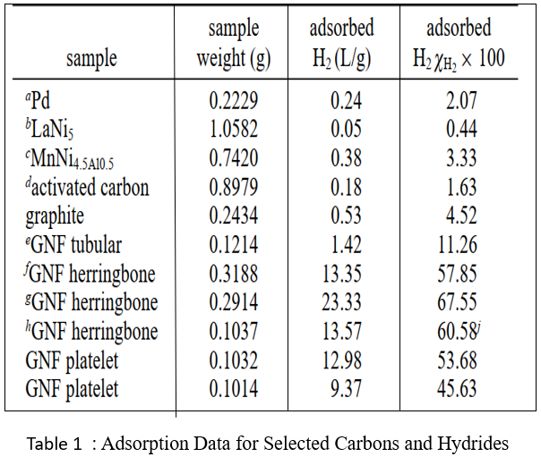](https://www.sciencedirect.com/science/article/abs/pii/S0360319916333602)

[](https://www.sciencedirect.com/science/article/abs/pii/S0360319916333602)

Figure 3 Change in hydrogen pressure as a function of time in the presence of Pd, LaNi (5), MnNi (4)**.** Al (0.5), Norit activated carbon, GNF tubular, GNF herringbone

1. Experiment Analysis of H2 adsorption study under flow (dynamic) conditions

Fig. shows a schematic representation of the experimental setup used for the H2 adsorption study under dynamic (flow) conditions. The setup included a shell-tube adsorber assembly. A stainless steel (SS) shell (L ¼ 140 mm, I.D. ¼ 14 mm) contained a SS tube (L ¼ 50mm, I.D. ¼ 4mm), which was closed at the top. Perforations of ~0.5mm-diameter were made over the middle section (25 mm-length) of the tube. The prepared adsorbent materials were wrapped over the perforated section. The H2 gas flowed from the bottom end into the perforated tubular reactor and radially outward through the test samples, before exiting from the top end of the SS shell. The gases (H2/ N2) were delivered from the cylinders and passed through the packed beds of silica gel and molecular sieve, which were installed in-line, to remove any moisture/impurities present in the gas cylinders. Gas flow rates were controlled using mass flow controllers.

The entire tubular reactor assembly was mounted in a liquid N2 container which could be moved up or down. The H2 (adsorbing gas) and N2 were mixed downstream of the tubular adsorber. Considering that N2 may be adsorbed at cryogenic temperature, H2 gas alone was passed through the adsorber. A gas chromatograph (GC) with the thermal conductivity detector (TCD) was used to measure the concentration of H2 in the H2eN2 mixed stream. Prior to the measurements, calibration was performed to correlate the GC signal with the concentration of H2 in the mixed stream, without using adsorbents in the adsorber. The flow rates of H2 and N2, delivered from the cylinders, were maintained constant. However, the flow rate of H2 post-adsorption varied with time. Therefore, H2-concentration in the H2eN2 mixed stream varied during the adsorption tests, which was measured using the GC. Gas samples were periodically drawn from the vent stream through a septum, using a gas tight syringe, and manually injected into the sample port of the GC. The N2 gas, received from a separate cylinder, was used as the carrier gas for the GC analysis. Before performing adsorption tests, a blank run was performed (without samples) under the identical conditions as in the tests to determine the adsorption of H2, if any, on the walls of the tubular adsorber and associated tubing, and the data were taken into consideration while determining the adsorption capacity of the prepared materials. All experiments were performed in triplicate to check the reproducibility and the data reported in this study are within ±5%.

[](https://www.sciencedirect.com/science/article/abs/pii/S0360319916333602)

Fig. Schematics of the experimental setup used for H2 adsorption study under dynamic (flow) conditions at 77 K.

**6. RESULTS AND DISCUSSION**

1. Results and discussion of Hydrogen Storage in Graphite Nanofibers
2. **Desorption of adsorbed hydrogen**

When the pressure of the system reached steady state, stored hydrogen was allowed to exit by opening a regulating valve, which enabled one to control both the pressure and rate of release of the gas. The volume of the desorbed fluid was subsequently measured by displacement of water. Analysis of samples of the discharged gas by GC-MS indicated that hydrogen was the only component present, dismissing the possibility that any catalyzed or uncatalyzed reactions had occurred between the graphite nanostructures and hydrogen during any of the operations. he differences in the volume of hydrogen recovered following interaction with graphite Nano- fibers was compared to the volume present in the system in the absence of the solid at equivalent pressures. This procedure enabled us to make an assessment of the amount of reversibly sobbed hydrogen stored in the nanofibers. The rate of release at room temperature of this fraction of hydrogen was, in most cases, extremely fast (5-10 min). This process was, however, normally conducted in a controlled fashion over a period of 1 h, to ensure that the integrity of the graphite nanofiber structure was preserved for subsequent adsorption cycles. Examples of these desorption data, which were obtained from a separate set of experiments, are presented in Table 2.

[](https://www.sciencedirect.com/science/article/abs/pii/S0360319916333602)

In all cases, it was observed that there was a difference in the amount of hydrogen adsorbed and desorbed at room temperature from the graphite nanofibers, suggesting the possible existence of chemisorbed hydrogen. In an attempt to gain a deeper insight into this phenomenon, samples of graphite nanofibers that had ostensibly been discharged of hydrogen were examined using temperature-programmed desorption (TPD). In this step nitrogen was passed over the sample as the temperature was ramped at 10 °C /min, and the evolved gases were measured using a TCD detector. It is evident from these data that a significant fraction of hydrogen is retained in the nanofibers and moreover, since high temperatures are required for complete desorption, one may conclude that chemical forces are involved in the adsorption of this strongly held hydrogen.

1. Results and discussion of H2 adsorption study under flow (dynamic) conditions
2. **Ni loading in Ni-ACF**

The prepared materials were characterized by their physicochemical properties, using various spectroscopic and analytical techniques such as atomic absorption spectroscopy (AAS), scanning electron microscopy (SEM), energy dispersive X-ray (EDX) spectroscopy, X-Ray diffraction (XRD), Raman spectroscopy, Brunauere Emmete Teller (BET) surface area and pore volume measurements and Fourier transform infrared (FTIR) spectroscopy. The Ni-metal loading in the ACF substrate was determined using AAS that was equipped with a deuterium background corrector, a hollow cathode lamp as the radiation source, and the air-C2H2 flame for the atomization of samples. The surface morphology of the prepared materials was observed using a field emission SEM. The elemental compositions were determined from the spectra recorded using the EDX.

The AAS analysis was performed on the impregnating solution, before and after impregnation. Prior to the analysis, calibration was performed using the standard solutions supplied by Varian. The Ni loading was determined to be ~360 mg/ g in the ACFs. The use of the SDS surfactant created a monodispersing of the salt in the impregnating solution, thereby facilitating a dense and uniform growth of the CNFs on the ACFs during CVD, discussed next.

1. **Surface morphology and EDX analysis**

Fig. 2 shows the SEM images of the prepared materials at low and high magnifications. The surface of the as-received ACF sample was smooth (Fig. 2a). Macro- and mesopores on the external surface of the sample were clearly visible (Fig. 2a'). The Ni NPs were dispersed across the ACF surface and in the pores of the Ni-ACF sample (Fig. 2b, b'). Fig. 2(c, c') confirms a dense and uniform growth of the CNFs on the ACF in the Ni- ACF/CNF sample. The shiny Ni NPs were located at the tips of the CNFs, indicating the growth of the CNFs on ACFs by the tip-growth mechanism. Similar texture was observed in the Ni-ACF/CNF-m sample. The texture of the CNFs remained intact after steam-activation (Fig. 2d, d'). The sonicated sample (ACF/CNF) was relatively less bright, because most of the shiny Ni NPs were removed from the tips of the CNFs during ultrasonication (Fig. 2e, e').

The area-EDX elemental mapping of the Ni-ACF/CNF-m sample showed a uniform dispersion of Ni in the ACF substrate (Fig. 3a). The spectra revealed the presence of Ni and carbon and the absence of oxygen, confirming that NiO was completely reduced to Ni0 state during the H2-reduction step. There were no other foreign impurities observed in the spectra. Fig. 3b shows the point-EDX spectra of the prepared sample, which confirmed the shiny NPs at the tips of the CNFs to be a Ni.

[](https://www.sciencedirect.com/science/article/abs/pii/S0360319916333602)

Fig. 2 SEM images of (a, a') ACF, (b, b') Ni-ACF, (c, c') Ni-ACF/CNF, (d, d') Ni-ACF/CNF-m and (e, e') ACF/CNF.

[](https://www.sciencedirect.com/science/article/abs/pii/S0360319916333602)

Fig. 3 e (a) Area-EDX elemental mapping and (b) point-EDX of Ni-ACF/CNF-m sample.

**7. CONCLUSIONS**

1. The ACF- and ACF/CNF-based adsorbents were prepared as an efficient H2-storage material.
2. The significance of the SBET or micro porosity, graphitic CNFs and the inclusion of Ni in the material were experimentally demonstrated for different adsorption temperatures.
3. The ACF substrate, which contained the highest SBET, showed the highest capacity (3.40% (w/w) at 20 bar) at 77 K, indicating that the BET surface area or the micro porosity of the adsorbent controlled H2-adsorption at cryogenic temperature. The steam modification of the Ni- ACF/CNF samples increased the BET surface area and micro porosity content, which were decreased in the post-CNF grown samples, but retained the graphitic texture of the material. The adsorption capacity of such adsorbent (Ni- ACF/CNF-m) was highest at elevated temperatures and 50 bar (0.56% (w/w) at 273 K and 0.75% (w/w) at 298 K), attributed to the synergistic effects of the metal, CNF and large SBET of the material.
4. Also, the prepared adsorbents were effectively used as the packed bed materials for the adsorption of H2 under flow conditions.
5. This study has shown that the textural properties of the material, including its metal content and graphitic characteristics must be considered while selecting a suitable adsorbent as the H2 storage material
6. **FUTURE SCOPE:**
7. Along with the continuous research on developing novel concepts and technologies with renewable energy application, in the past decades there have been numerous attempts to develop nanomaterials to achieve applicable renewable energy conversion and utilization.
8. The concepts of nanomaterial design for high efficiency photocatalytic/photoelectrochemical solar hydrogen conversion, high capacity hydrogen storage, and effective electricity generation from fuel cells.
9. Although there are still many challenges ahead in these areas, the review article presented here demonstrates that nanomaterial design is important for future research into these selected technologies for renewable energy.
10. It is anticipated that new strategies and advanced functional nanomaterials will continue to emerge due to the active research and development of the hydrogen storage, which would contribute significantly to a successful implementation of the hydrogen economy vision.
11. **REFERENCES**
12. [Hydrogen storage in carbon materials—A review](https://onlinelibrary.wiley.com/doi/full/10.1002/est2.35)
13. [Hydrogen Storage in Carbon Nanofibers](http://www.sciencedirect.com/science/article/pii/S0008622300003067)
14. [Nickel nanoparticle-doped and steam-modified multiscale structure of carbon micro-nanofibers for hydrogen storage: Effects of metal, surface texture and operating conditions](https://www.bing.com/search?q=Nickel+nanoparticle-doped+and+steam-modified+multiscale+structure+of+carbon+micro-nanofibers+for+hydrogen+storage:+Effects+of+metal,+surface+texture+and+operating+conditions&cvid=a58967b4df4d4860b1eab28ad9fda395&aqs=edge..69i57.1238j0j1&pglt=931&FORM=ANNTA1&PC=ACTS)
15. [Hydrogen storage - Wikipedia](https://en.wikipedia.org/wiki/Hydrogen_storage)